**A.A.GOVERNMENT ARTS COLLEGE, MUSIRI**

Affiliated to Bharathidasan University, Tiruchirapalli.

NAAN MUDHALVAN PROJECT-III BSC MATHEMATICS

Topic:

UNLOCKING INSIGHTS INTO THE GLOBAL AIR TRANSPORTATION NETWORK WITH TABLEAU

Submitted by

TEAM ID : NM2023MID08284 TEAM LEARDER: PRADEEP.V(F63ABC5C6D783E296114985962DC84AA)

MEMBERS: BALUCHANDIRAN.P(860EDD0E0061ECB815343259FD4002D2)

GUNA.J(F4A594517C11BDEB1ED461B1A9104D3D)

NANDHAKUMAR. R(77F9241F0D7462A8D4D4AE2178B5C740)

***INTRODUCTION :***

***This Global Air Transportation Network dataset is a comprehensive collection of information on airports , airlines and their routes. It contains information such as names , cities , countries , codes(IATA AND ICAO) longitudes , latitudes and altitudes of airports across the world with detailed time zone and daylight saving time data .***



***Milestone 1: DEFINE PROBLEM :***

***Problem Understanding , also known as problem Definition or problem Identification , is the initial and critical phase of any data analysis or problem-solving process .*** 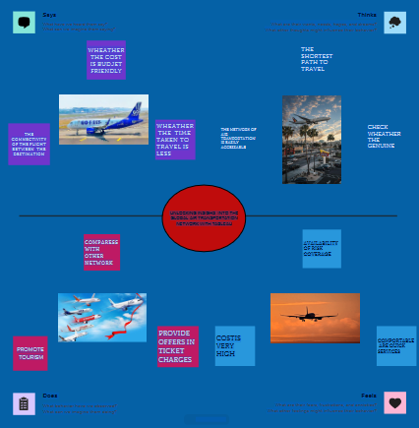

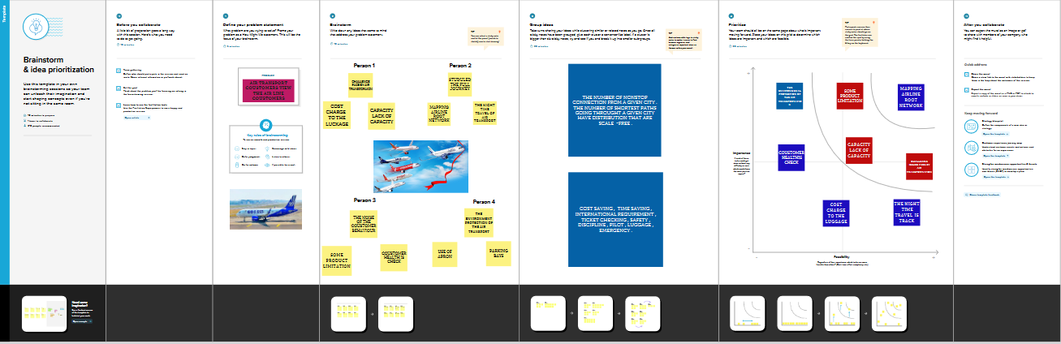

**REFERENCE**

* Sun X, Cao X (2015) Computationally Transport Science11:939–966
* Guess W, Vehicle M, Program G (2017) Global network centrality of university rankings. R Open Science 4:171172
* A (2006) Pre- diction and predictability of global epidemics: the role of the airline transportation network. Project Academy Science: PNAS 103:2015–2020

A (2006) The role of the airline transportation network in the prediction and predict- ability of global epidemics. Project and Academy Science 103:2015–2020 .

* London O, Salem J, Simon P, Gonzalez-Prieto D (2015) Robustness of airline alliance route networks. Common Nonlinear
* Science Number Simon 22:587–595
* efficient attack design for robustness analysis of air transportation networks. Transport A



***MILESTOME 2 DATA COLLECTION***

Activity 1. Downloving the dataset

y

Activity 2. Connect Data Set with Tableau

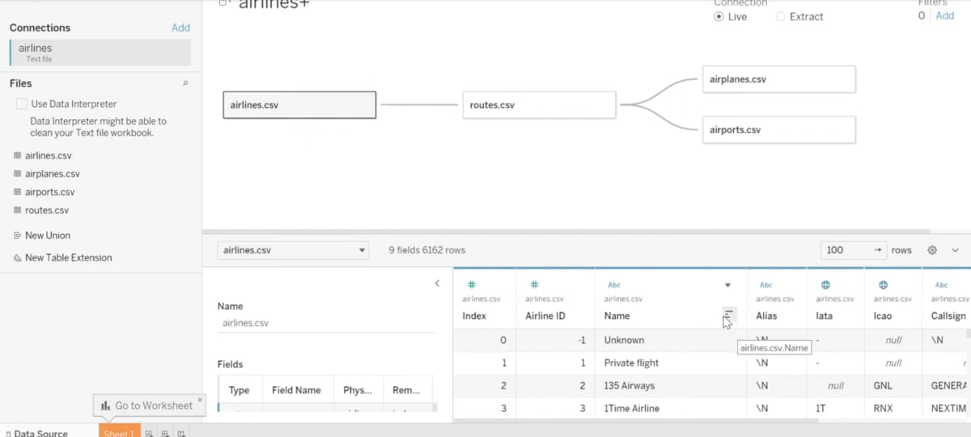

MILESTONE 3 : Data Preparation

*The right data, harnessed in the right way, can deliver actionable insights that are truly transformative for decision-making, efficiency and smooth passenger-focused delivery of services. Jim Peters, Chief Technology Officer at SITA, reveals how big data is beginning to deliver real value in the air transport industry.*

MILESTONE 4: Data visualization

***Data visualization is the representation of data through use of common graphics, such as charts, plots, info graphics, and even animations.***

Activity 1: Data visualization

The number of unique visualizations that can be with a dataset.

*Activity 1.1 world map showing details of all airports with in a country.*

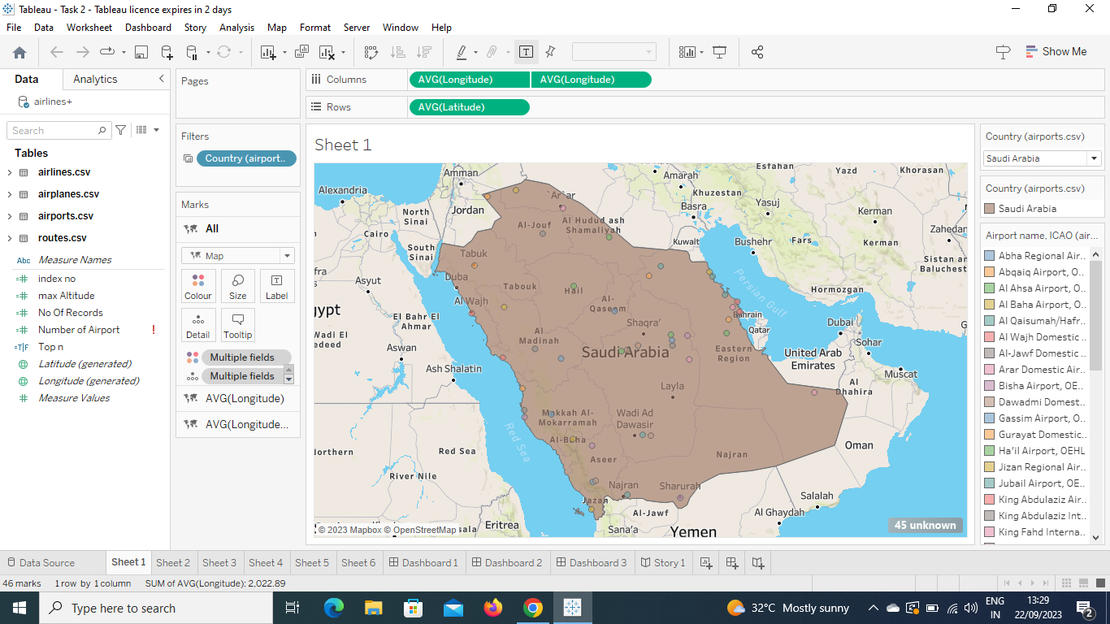

Activity 1.2 Number of airports with in the country .

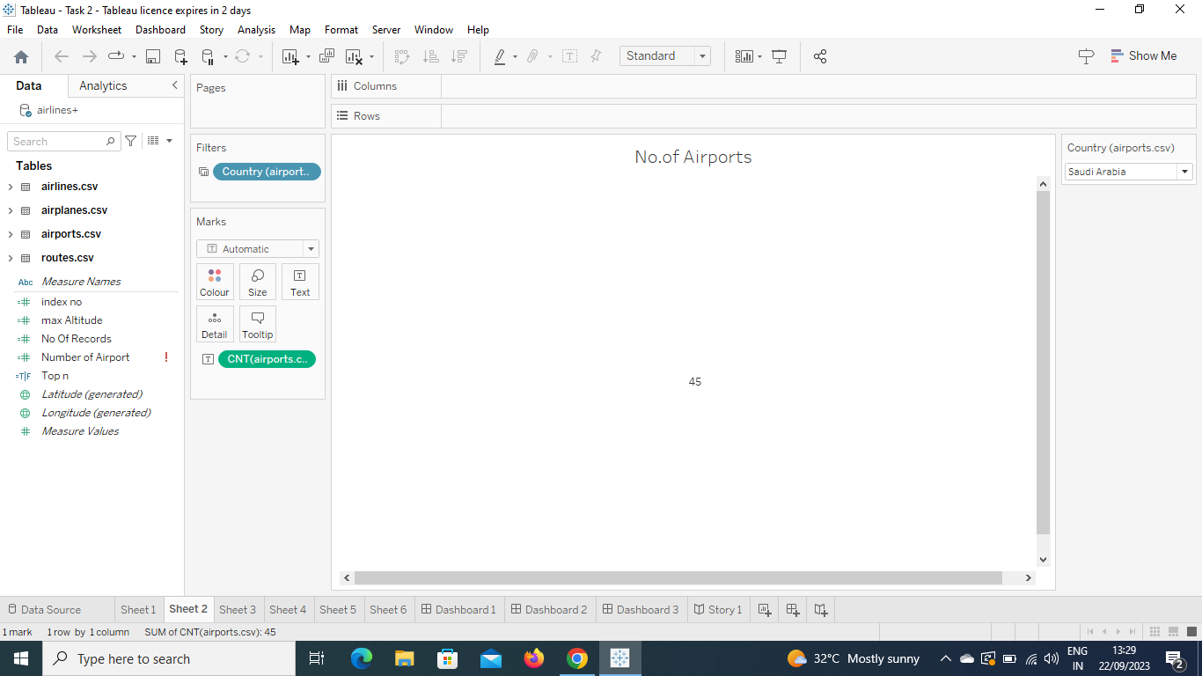

Activity 1.3 Airports at higher altitude within a country.

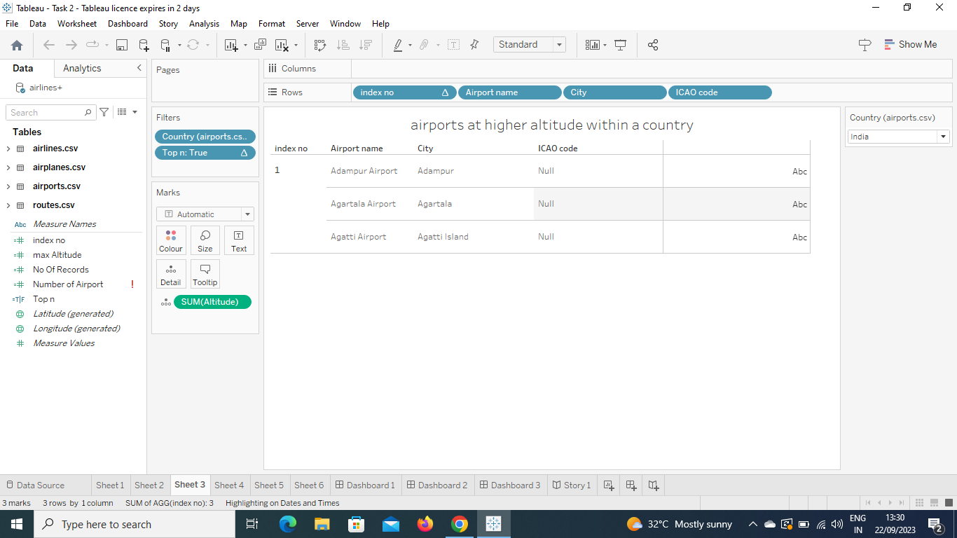

Activity 1.4 Airports at higher altitude in the world.

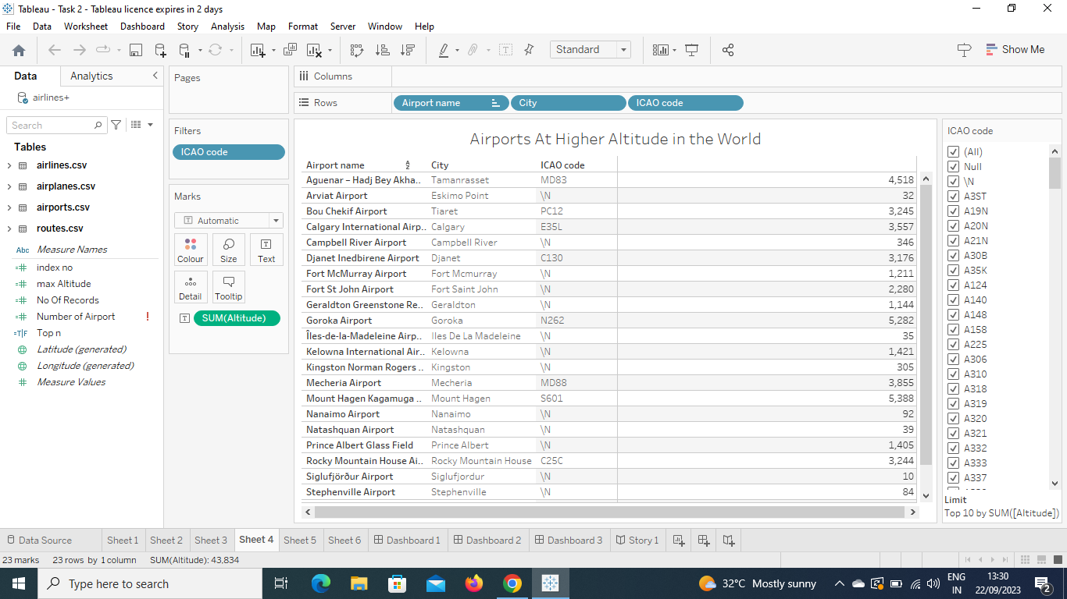

Activity 1.5 Airlines with in a country.

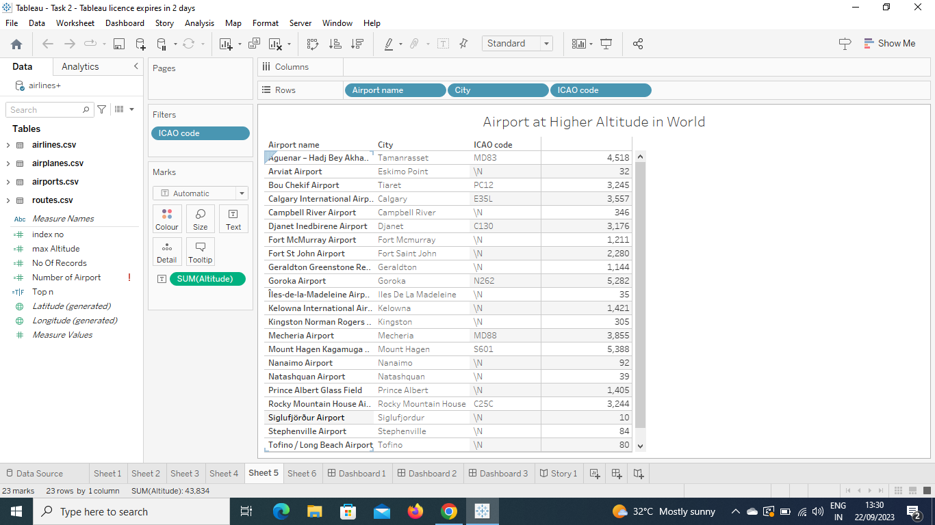

Activity 1.6 Number of flights from airport.

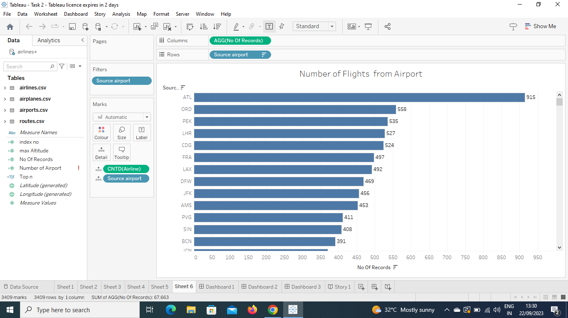

MILESTONE 5 DASHBOARD

Activity 1 Responsive and design of dashboard

A dashboard is a graphical user interface (GUI) that displays information and data in an organized, easy-to-read forma. Dashboards are often used to provide real-time monitoring and analysis of data, and are typically designed for a specific purpose or us case. Dashboards can be used in a variety of settings, such as business, finance, manufacturing, healthcare and many other industries.

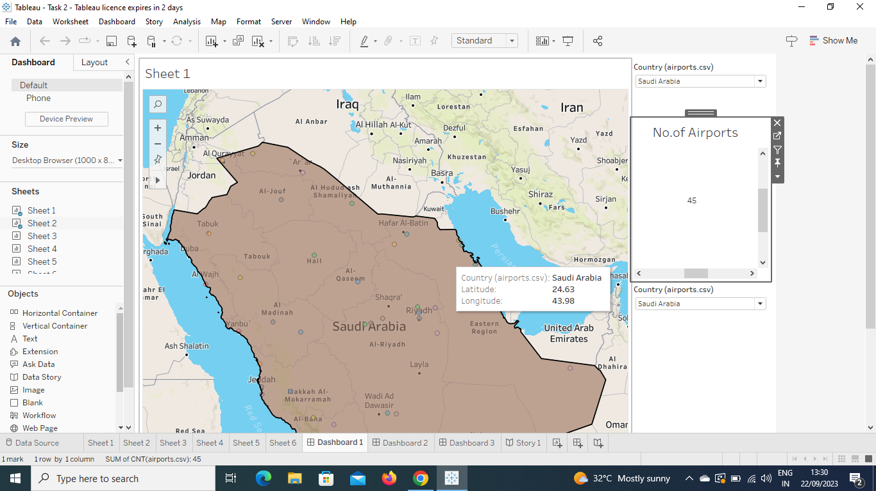

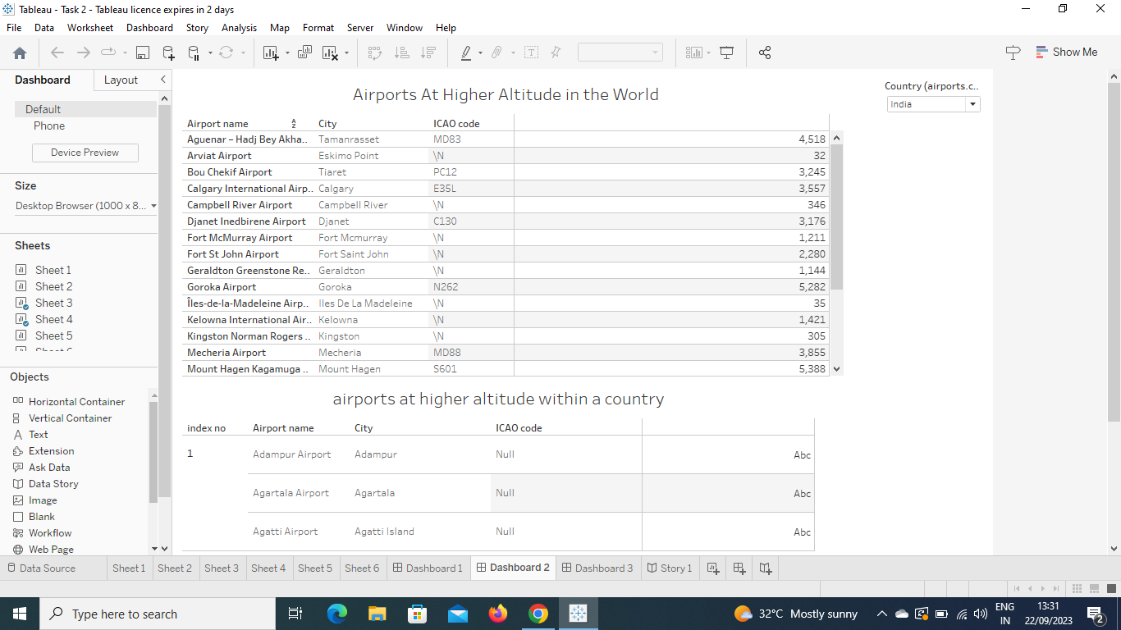

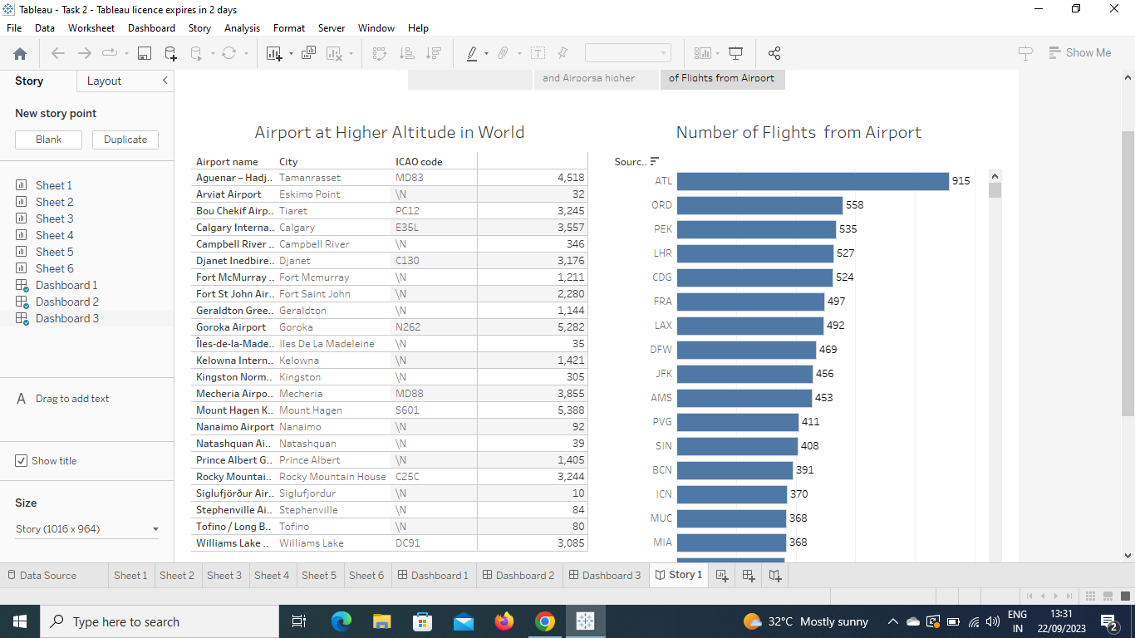

Milestone 6:Story

Activity:1-No of Scenes of Story

A data story is a way of presenting data and analysis in a narrative format , with the goal of making the information more engaging and easier to understand. A data story typically includes a clear introduction that sets the stage and explains the context for the data, a body that presents the data and analysis in a logical and systematic .





MILESTONE 7: Performance Testing

Activity 1 : Amount of data rendered to tableau

The amount of data is rendered to a tableau depends on the size of the dataset.

Activity 2 : Utilization of filters











Activity 3 : No of calculation Fields

Tables

**Airlines.csv** Altitude

**Airplanes.csv** End pt

**Airports.csv** Index ( Airports.Csv)

**Routews.csv** Latitude

Measure names Longitude

Index no. max altitude Start pt

Number of airports Timezone

Top n airports.csv (Count)

Latitude(generated)

Longitude(generated)

Measure values

***MILESTONE 8: PUBLISHING***

***DASHBOARD 1***

[***https://public.tableau.com/views/Dashboard1_16952680267660/Dashboard1?:language=en-US&publish=yes&:display_count=n&:origin=viz_share_link***](https://public.tableau.com/views/Dashboard1_16952680267660/Dashboard1?:language=en-US&publish=yes&:display_count=n&:origin=viz_share_link)

***DASHBOARD 2***

[***https://public.tableau.com/views/Dashboard2_16952774475230/Dashboard2?:language=en-US&publish=yes&:display_count=n&:origin=viz_share_link***](https://public.tableau.com/views/Dashboard2_16952774475230/Dashboard2?:language=en-US&publish=yes&:display_count=n&:origin=viz_share_link)

***DASHBOARD 3***

[***https://public.tableau.com/views/Dashboard3_16952781108580/Dashboard3?:language=en-US&publish=yes&:display_count=n&:origin=viz_share_link***](https://public.tableau.com/views/Dashboard3_16952781108580/Dashboard3?:language=en-US&publish=yes&:display_count=n&:origin=viz_share_link)

***STORY***

[***https://public.tableau.com/views/Story1_16952784184950/Story1?:language=en-US&publish=yes&:display_count=n&:origin=viz_share_link***](https://public.tableau.com/views/Story1_16952784184950/Story1?:language=en-US&publish=yes&:display_count=n&:origin=viz_share_link)

CONCLUSION :

*Almost half of the world’s population is carried by airlines*

*each year, and understanding this mode of transport is*

*important from economic and scientific perspectives. In*

*this case study paper, we reviewed both bottom-up (max.*

*entropy agent model) and top-down (network science)*

*approaches to better understand the fundamental science*

*behind air transport networks. A summary of key findings is given.*

simple socioeconomic indicators, we

were able to construct a very accurate entropy-maximization interaction model that can predict transfer volume for

Australia. Using the population and distance functions, the

spatial interaction model can forward estimate the impact

of population growth. In Sect. 3.2, using historical data,

we were able to identify how hubs evolved over time to

become more influential. In Sect. 4, looking into the future,

using random graph theory, it seems that reduced fight

cost will lead to increased hub influence